# **Kanban and Lean Principles - Summary**

## **Kanban**

**Kanban** is a **visual workflow management method** used to optimize work and improve efficiency. 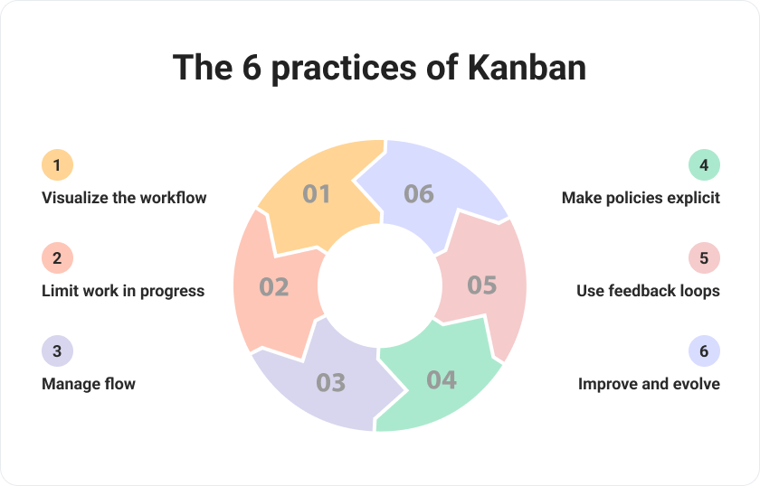

### **1. Visualize the Workflow**

* **Meaning:** Show every step of your work on a board.
* **Simple:** You can see what tasks are "To Do," "In Progress," and "Done" — just like sticky notes on a wall!

### **2. Limit Work in Progress (WIP)**

* **Meaning:** Set a limit on how many tasks you work on at the same time.
* **Simple:** Don’t start too many things at once — finish what you started first.

### **3. Manage Flow**

* **Meaning:** Keep tasks moving smoothly from start to finish.
* **Simple:** Make sure work doesn't get stuck anywhere — like water flowing in a river.

### **4. Make Policies Explicit**

* **Meaning:** Clearly define the rules for how tasks move.
* **Simple:** Everyone should know the rules — for example, "Only 3 tasks can be In Progress at a time."

### **5. Use Feedback Loops**

* **Meaning:** Regularly review and improve your work through meetings.
* **Simple:** Talk often with your team to catch problems early and improve.

### **6. Improve and Evolve**

* **Meaning:** Continuously find ways to get better.
* **Simple:** Always look for small changes that can help you work faster and smarter.

### **🔹 Why Kanban?**

* Easy to adopt without major changes to the current process.
* Helps identify and fix slow points (bottlenecks).
* Improves team focus and faster delivery.

## 

## 

## 

## 

## 

## **Lean Principles**

**Lean** comes from **Lean Manufacturing (Toyota)** and aims to **maximize value** while **minimizing waste**. 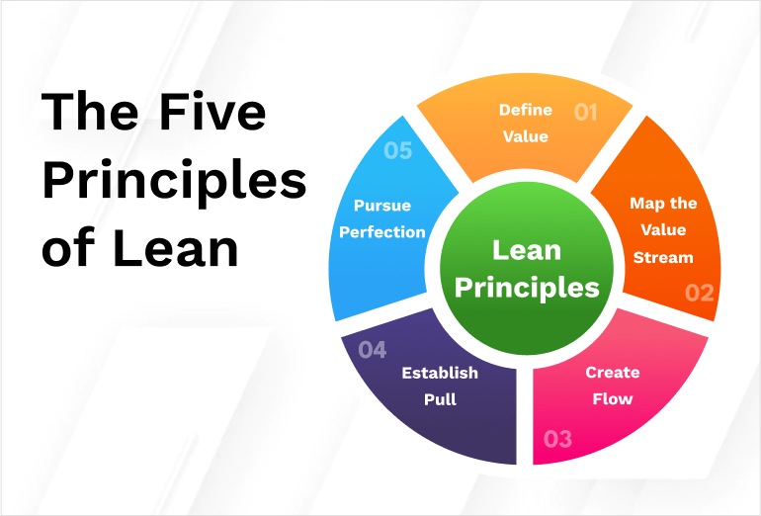

### **🔹 Core Principles:**

1. **Value:** Define what is truly valuable from the customer’s point of view.
2. **Value Stream:** Map out the steps that deliver value and eliminate steps that don't.
3. **Flow:** Ensure the work progresses smoothly without interruptions.
4. **Pull System:** Produce only when there is demand (similar to Kanban’s pull of work).
5. **Continuous Improvement (Kaizen):** Always look for ways to improve processes and reduce waste.

### **🔹 Why Lean?**

* Reduces unnecessary work.
* Speeds up delivery by focusing only on what matters.
* Builds a culture of continuous improvement.

# **Quick Comparison:**

| **Aspect** | **Kanban** | **Lean** |
| --- | --- | --- |
| Focus | Workflow visualization | Eliminating waste |
| Method | Pull-based, visual tasks | System-wide thinking |
| Delivery | Continuous | Continuous |
| Goal | Improve task flow | Maximize value, minimize waste |